ULTRASONIC TESTING REPORT
Company/Client |  | NCOC N. V. |  | Project |  | ESKENE WEST |  | Location |  | KUT - 570
Line No/Tag No: |  | A1-5700-WW-001-1"-NI2.4-HC |  | Material |  | Pipe:B167- N06600;  Elbow: B366; |  | Día × Nominal Thickness |  | ¾”x2.87 mm  1”×3.38 mm  2”x3.91 mm
Procedure No: |  | QP-11-UTT-Q01 Rev 03  GOST 28702-90 |  | Calibration Block |  | Step wedge |  | Probe  S/N |  | D7908  1214571
 |  |  |  | Calibration block Range |  | 2.5-25.0 mm |  | Angle |  | 0º
Manufacturing Code |  | ASME B31.3 |  | Calibration Temp |  | +33ºC |  | Frequency |  | 7.5 MHz
 |  |  |  | Object Temp |  | +35  ºC |  | Size |  | 5.1 mm
Acceptance Standard: |  | Acc. to the client specif. |  | Correction factors |  | n/a |  | Crystal |  | Dual
Surface condition |  | Uncoated |  | Couplant |  | UT Gel |  | Accuracy |  | ± 0,1 mm
№ | Equipment/  Material Name |  | Manufacturer |  | Serial № |  | Calibration certificate № |  | Calibration Expiry date
 | DL-38 |  | OLYMPUS |  | 183107401 |  | BK-01-0079 |  | 05-02-2021
 | Step wedge calibration block |  | NDE-TECH |  | NDE-8365 |  | - |  | -
Job description:

- UT spot check performed on line A1-5700-WW-001-1"-NI2.4-HC (drawing No KE01-A1-570-MT-P-D1-1001-107).
- P&ID scheme No is KE01-A1-570-MT-R-HP-0024-008.
- Standard UT technique was used.
- Inspection performed on East, West, South, North and Extrados from external.
Notes:
N/A – not applicable.
FSH - Full Screen Height

Inspection drawing
KE01-A1-570-MT-P-D1-1001-107
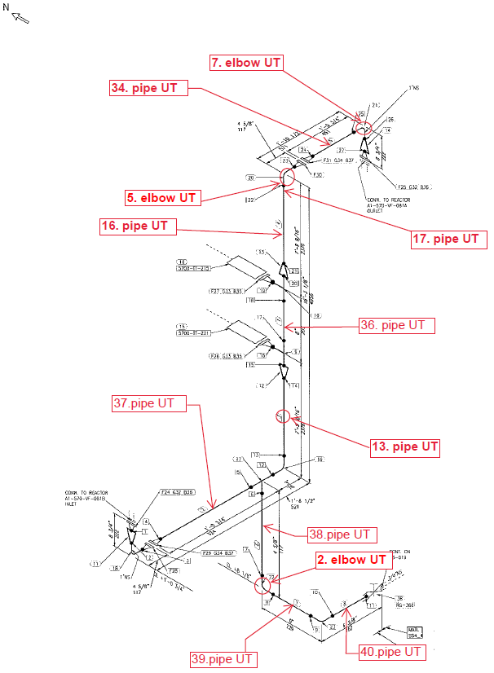
35. Tee UT
15. Tee UT
12. Reducer UT
UT-N2 Nozzles of A1-570-VF-081A

Inspection results
№ | P&ID | Isometric № | Line № | Item description | Spot check | DIA(Ø), inch | Nominal thickness, mm* | East  mm | West  mm | South  mm | North  mm | Top  mm | Bottom  mm | Extrados  mm
1 | KE01-A1-570-MT-R-HP-0024-008 | KE01-A1-570-MT-P-DI-1001-107 | A1-5700-WW-001-1"-NI2.4-HC | Elbow-2 | 1 | ¾ | 2.87 | 2.67 | 2.67 | - | - | - | - | 2.53
 |  |  |  | Elbow-5 | 1 | 1 | 3.38 | - | - | 3.12 | 3.04 | - | - | 2.55
 |  |  |  | Elbow-7 | 1 | 1 | 3.38 | - | - | 2.62 | 2.61 | - | - | 2.31
 |  |  |  | Reducer-12 | 1 | 2x1 | 3.91 | 3.64 | 3.69 | 3.19 | 3.30 | - | - | -
 |  |  |  | Pipe-13 | 1 | 1 | 3.38 | 3.43 | 3.27 | 3.34 | 3.39 | - | - | -
 |  |  |  | Tee-15 | 1 | 2 | 3.91 | 5.64 | 6.01 | 6.10 | 4.56 | - | - | -
 |  |  |  |  | 2 | 2 | 3.91 | 5.35 | 5.59 | 6.00 | - | - | - | -
 |  |  |  |  | 3 | 2 | 3.91 | 5.70 | 6.01 | 5.78 | 5.76 | - | - | -
 |  |  |  | Pipe-16 | 1 | 1 | 3.38 | 3.37 | 3.48 | 3.41 | 3.45 | - | - | -
 |  |  |  | Pipe-17 | 1 | 1 | 3.38 | 3.28 | 3.43 | 3.47 | 3.44 | - | - | -
 |  |  |  | Pipe-34 | 1 | 1 | 3.38 | - | - | 2.78 | 2.80 | 2.88 | 2.80 | -
 |  |  |  | Tee-35 | 1 | 2 | 3.91 | 5.84 | 5.97 | 6.17 | 6.71 | - | - | -
 |  |  |  |  | 2 | 2 | 3.91 | 5.37 | 5.20 | 6.17 | - | - | - | -
 |  |  |  |  | 3 | 2 | 3.91 | 5.30 | 5.36 | 6.01 | 4.28 | - | - | -
 |  |  |  | Pipe-36 | 1 | 2 | 3.91 | 3.53 | 3.71 | 3.67 | 3.87 | - | - | -
 |  |  |  | Pipe-37 | 1 | 1 | 3.38 | - | - | 3.31 | 3.28 | 3.40 | 3.38 | -
 |  |  |  | Pipe-38 | 1 | ¾ | 2.87 | 2.76 | 2.72 | 2.78 | 2.73 | - | - | -
 |  |  |  | Pipe-39 | 1 | ¾ | 2.87 | 2.88 | 2.94 | - | - | 2.85 | 2.95 | -
 |  |  |  | Pipe-40 | 1 | ¾ | 2.87 | - | - | 2.76 | 2.77 | 2.73 | 2.78 | -

*according to ASME B36.10-B36.19 schedule 40

Inspection drawing
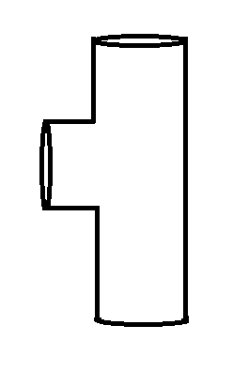
3
2
1
Tee - check spot

Inspection drawing
A1-570-VF-081A

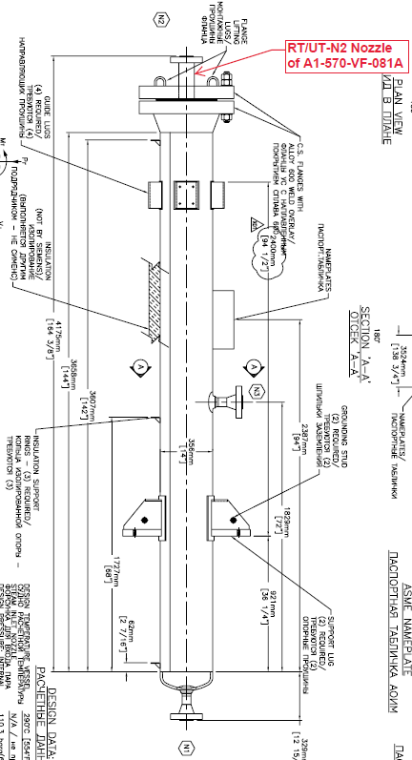
Inspection results
S/NO | P&ID | Isometric No | Reactor No | Item description | DIA(Ø), inch | Nominal thickness, mm* | East  mm | West  mm | South  mm | North  mm | Top  mm | Bottom  mm
1 | KE01-A1-570-MT-R-HP-0024-008 | KE01-A1-570-MT-P-DA-0310-001. | A1-570-VF-081A | Nozzle N2 | 2 | 27.0 | 22.95 | 22.91 | 22.87 | 22.98 | - | -

Examined by  UT L II cert. No. 811  exp. date 10.04.2022 | Name: Akhmadaliyev Roman | Signature: ............................... | Date: 10 Jun 2020
Approved by  UT L II cert. No 1A 167/17  expiry date 31.01.2022 | Name: Barsukou Raman | Signature: ........................... | Date: 10 Jun 2020
Client Representative: | Name: …………………………… | Signature: .............................. | Date: ……………………

